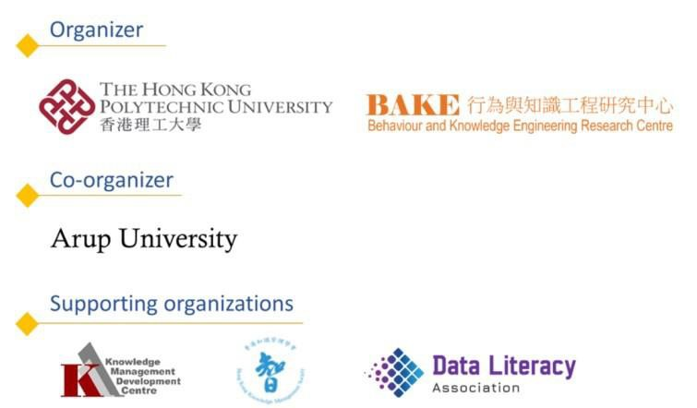
https://www.hkmikeaward.com

Hong Kong Most Innovative
Knowledge Enterprise Award
Application Form & Assessment Model
Hong Kong MIKE Award 2026

Table of Content
Application & Rules
  - Type of Application
  - Application Form
  - Terms and Conditions
  - Submission Guidelines
  - Submission Checklist

I. Assessment Form
Part A: MIKE Intellectual Capital Assessment Criteria
° Criteria 1: Empowering knowledge workers for innovation
° Criteria 2: Strategic, visionary, and transformative leadership
° Criteria 3: Living up to customer and stakeholder expectations and needs
° Criteria 4: Developing internal & external networks and connectivity
° Criteria 5: Cultivating an organizational innovation culture
° Criteria 6: Investing in and delivering knowledge-based products/services/solutions
° Criteria 7: Enforcing knowledge practices and systems for knowledge creation
° Criteria 8: Implementing creative and virtual concepts/ spaces to create stakeholder value

° Criteria Ranking Part B: Innovation Performance
Appendix Documents

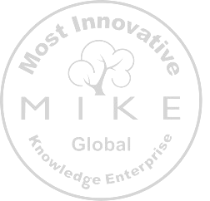Application & Rules
Hong Kong MIKE Award 2024 – V1-0 - Revised on 9 February
Please fill up this form in English language only

Type of Application

Please choose one of the followings:

    - We wish to go through the normal judging process and compete for the Hong Kong MIKE Award, including Most Outstanding Winner.

    - We are the past winner of Hong Kong MIKE Award (year). We wish to retain the title of Hong Kong MIKE Award winner through the revalidation process.

Application Form

In which of the 5 MIKE categories would you like to apply (select only ONE that matches your organization profile)?
- Large private organizations
- Government organizations
- State Enterprise Companies
- Associations, Institutions and non-profits
- SMEs - Startups

Name of Company / Organization:
(The name stated here will be displayed in all promotion and collateral materials associated with the Award including Trophy and Certificate. No change is allowed after submission.)
Contact Details
Name:

Position:

Address:

Country:

Tel No.:

E-mail Address:

Company/ Organization Details
Business Registration No.:

(For public organization without a Business Registration number, please fill in "0" in the field.)
Type of Organization:
(e.g. Private/ NGO/ Government)

Type of Business: Local / National / International

Please State the Business Group / Unit:
(if any)

Total Number of Employees:
(i.e. the units in which the KM applies and spreads to)

Listed Company/ Organization in Stock Market:
Yes / No

Date of Establishment: / /
yyyy / mm / dd

Website: http://

Company Logo
(png, jpg or ai file format)
Please provide your company logo via email.

To whom the invoice should be addressed to (please provide full name, address, email, company Tax Number, if any)

Category of Business:
(Please choose the most suitable category)
- Agriculture| Fishing| Mining| Energy| Forestry
- Medical services
- Manufacturing (i.e., Automotive Parts, Garment)
- Bio Food Technology
- Construction| Housing
- Financial services and banking
- Trading and Logistics
- Professional services and other producer services
- Retail and food services
- Public administration, social services, NGO and government departments
- Tourism| Hotels
- Education services
- Public transportation| Shipping| Aviation
- Entertainment, publishing and media
- Telecommunications | IT
- Others (Please specify: )

Knowledge Management Department
Number of Knowledge Management staff.: Full time: Part Time: To which business unit the KM department
reports to: (e.g. HR, IT, ….)

What is the name of the department in
charge of KM?:

Person in Charge of KM, contact info: Name:
Email: Position:
Is your organization planning to become Yes / No / Thinking about it
ISO 30401 certified (KM certification standard)? :

Additional comments about your KM department?

Innovation Management Department
Number of Innovation Management staff.: Full time: Part Time: To which business unit the Innovation
Management department reports to: (e.g. HR, IT, ….)

What is the name of the department in charge of Innovation Management?:

Person in Charge of Innovation Management, contact info:
Name: Email: Position:

Is your organization planning to become ISO 56002 certified (Innovation Management certification standard)? :
Yes / No / Thinking about it

Additional comments about your Innovation Management department?

Quick survey¹ about the state of KM and Inn ovation Management in your organization. This information is not part of the MIKE Assessment, but it will help us better understand how these disciplines are evolving for Hong Kong MIKE Award candidates. Data will remain confidential and be aggregated for analysis. Thank you for your answers.
How do you expect your organization's investment in KM and Innovation to change over the near-term future (next 12—18 months)? Select one for each:

KM
  - Increase a lot
  - Increase a little
  - Stay about the same
  - Decrease a little
  - Decrease a lot
  - Not sure/Not applicable
Innovation
  - Increase a lot
  - Increase a little
  - Stay about the same
  - Decrease a little
  - Decrease a lot
  - Not sure/Not applicable

¹ Adapted from APQC annual KM survey

Which business priorities is it most important for KM to enable or support right now?

Select up to three:

- Operational efficiency/process improvement
- Continuous learning
- Intelligent enterprise
- Data-driven decision making
- Strategic integration
- Employee experience
- Digital transformation
- Not sure/Not applicable
- Productivity
- Innovation and experimentation
- Organizational agility
- Customer centricity/experience
- The Future of Work
- Quality
- Cost savings
- Diversity, equity and inclusion
- Others

What are the biggest opportunities for KM to capitalize on right now? Select up to three:

- More leaders are recognizing and treating knowledge as a strategic asset
- KM partnership with core business functions and subject matter experts
- KM can show its value by supporting digital transformation/workplace initiatives
- New technology like Al can help KM scale and deliver more value
- Leaders are recognizing the risk of knowledge gaps and siloes
- KM is essential as organizations strive to reskill and upskill employees
- KM is essential as organizations normalize remote/hybrid work
- KM is essential as organizations strive to become more innovative
- KM partnership with shared functions like IT and HR
- Employees are frustrated with chaotic, disorganized information repositories
- Employee retirements and churn make it critical to capture/transfer knowledge
- Other:

- Not sure/Not applicable

What are the biggest threats to KM right now?

Select up to three:

- Employees are overworked and don't think they have time for KM
- KM'S impact is hard to measure, which complicates funding and buy-in
- Leaders are focused on (what they see as) more urgent problems or opportunities
- People are dealing with a lot of change, which makes it harder to motivate new behaviors
- Organizational culture does not incentivize knowledge sharing and reuse

- KM may get lost in broader digital transformation/intelligent enterprise strategies
- Organizations have too many disconnected technologies in place to support
- KM may get lost in broader future of work strategies
- Organizations don't have sufficient technology in place to support KM
- Legal and ethical challenges due to new technology capabilities
- New technology like Al eliminates the need for KM
- Other:
- Not sure/Not applicable

Terms and Conditions

Applicants must accept the following Terms and Conditions to join the Hong Kong MIKE Award.
    - We give our consent to hosting organization / country representative / proposer to send the submitted personal data to the administration unit of Hong Kong MIKE Award for the use of processing the award.
    - We agree to the Terms and Condition of Hong Kong MIKE Award as stated in the following pages.

Full Name:

Position:

Signature:

Date: / /

Terms and Conditions of the Hong Kong MIKE Award
Entrants for the Hong Kong MIKE Award are bound by the terms and conditions of the Award. Please read carefully the following terms. Failure to comply may lead to rejection or disqualification of the entry.
Terms and Conditions:
- The entrant’s name (i.e. the name of the organization) stated in the application form will be displayed in all announcements, promotion and collateral materials associated with the Hong Kong MIKE Award.
- The use of data as contained in the application will conform to the law in the countries where the administration unit of Hong Kong MIKE Award, country host, and Award Presentation Ceremony event organizer are based.
- The entrant is required to enter the Business Registration number when lodging their application and may be further asked to submit the Business Registration document for verification. For public organization without a Business Registration number, please fill in "0" in the application form.
- The entrant must ensure the report, including all design and work submitted, does not infringe the intellectual property rights of any third party. The organizer will not be responsible for any such

infringements in whatsoever and entrants found to have committed intellectual property right infringements will be disqualified immediately. Application fee will NOT be refunded.
- The entrant must adhere to the schedule and submit their report on time. Late submission will not be considered.
- All information, including the logo of the organization, will be used by the organizer strictly for purposes related to the Award. This information may be disclosed and transferred thereof to the organizer’s employees, officers, legal advisors, or judging panel of the Award on a need-to-know basis and only to the extent necessary for each of them to perform his/her duties.
- An awardee agrees to allow the organizer to use its organization name, logo and photos in the promotion and publicity materials of the Award.
- The awardee agrees to let the organizer anonymously use its submitted information on research study and publication purpose.
- The awardee agrees to share their submission to other awardees and hosts of country MIKE Award on a platform. The Awardee has the right to edit its original material (i.e. consolidate to 4-7 pages in a single story) to make it suitable for sharing.
- Subject to Clauses 9, the awardee agrees to treat the submission made by the other awardees pertaining to this Award as confidential information (verbal, written or electronic format). The awardee agrees not to disclose or use any of the proprietary information unless it is already known to the awardee prior to the viewing. The awardee also agrees to make no copies in any form of any documents which contain such confidential information.
- The entrant agrees not to make any claim or bring any action against the organizer and members of the Judging Panel for any reason whatsoever, or otherwise seek to recover from the organizer and members of the Judging Panel, any costs incurred in relation to the Award or any lost expectation of profits or any other benefits which the entrant may expect to accrue from participating in the Award.
- An entered application cannot be withdrawn once the assessment process has commenced. The materials submitted by the entrants cannot be returned.
- The operational details of running the Award such as deadlines of submission, dates of announcement, award ceremony, trophy arrangement etc. are subject to announcement by the organizer from time to time. The organizer reserves the right to make such changes according to the prevailing conditions.
- The terms and conditions are subject to change by the organizer when necessary. The organizer reserves the right to revise to the rules of the Award without prior announcement. The document is available on Hong Kong MIKE Award Website: https://www.hkmikeaward.com/
- All matters and disputes are subject to the final decision of organizer of the Hong Kong MIKE Award.

Submission Guidelines
Guidelines for Preparing your Successful Story Submission deadline: 27th Aug 2026
The submission package should include the completed application form, report, and required supporting documents.
- The report is composed of Part A, Criteria Ranking, Part B and Appendix Documents in the format as follows.
- A4-size, with single-lined spacing and minimum font size of 12 points
- Maximum 2 pages per criteria for Part A
- Maximum 1 page per measurement for Part B (including tables and figures)
- Appendix Documents (optional, such as company annual reports, articles, newspaper clippings etc.; maximum of 5 items)
- Start a new page for each section

- Payment information
- Application Fee: HKD3,000
- This fee includes the review of the application by our International Expert committee as well as the Trophy + Certificate + 1 seat for the Hong Kong MIKE Award Ceremony.
- If you do cannot physically attend the award ceremony to receive your trophy and certificate, we will be able to send it to you with extra delivery cost.
- When you submit your application to BAKE.info@polyu.edu.hk we will send you an invoice for payment.

I.5 Submission Checklist

- Choose type of application
- Fully filled in application form (and please double check that your company name is properly stated as you would like it to appear on the Trophy and Certificate)
- Terms and conditions form signed
- Company logo (.png, or .jpg or .ai) submitted by email
- Assessment form completed (2 pages max per criteria)
- Appendices (if any)

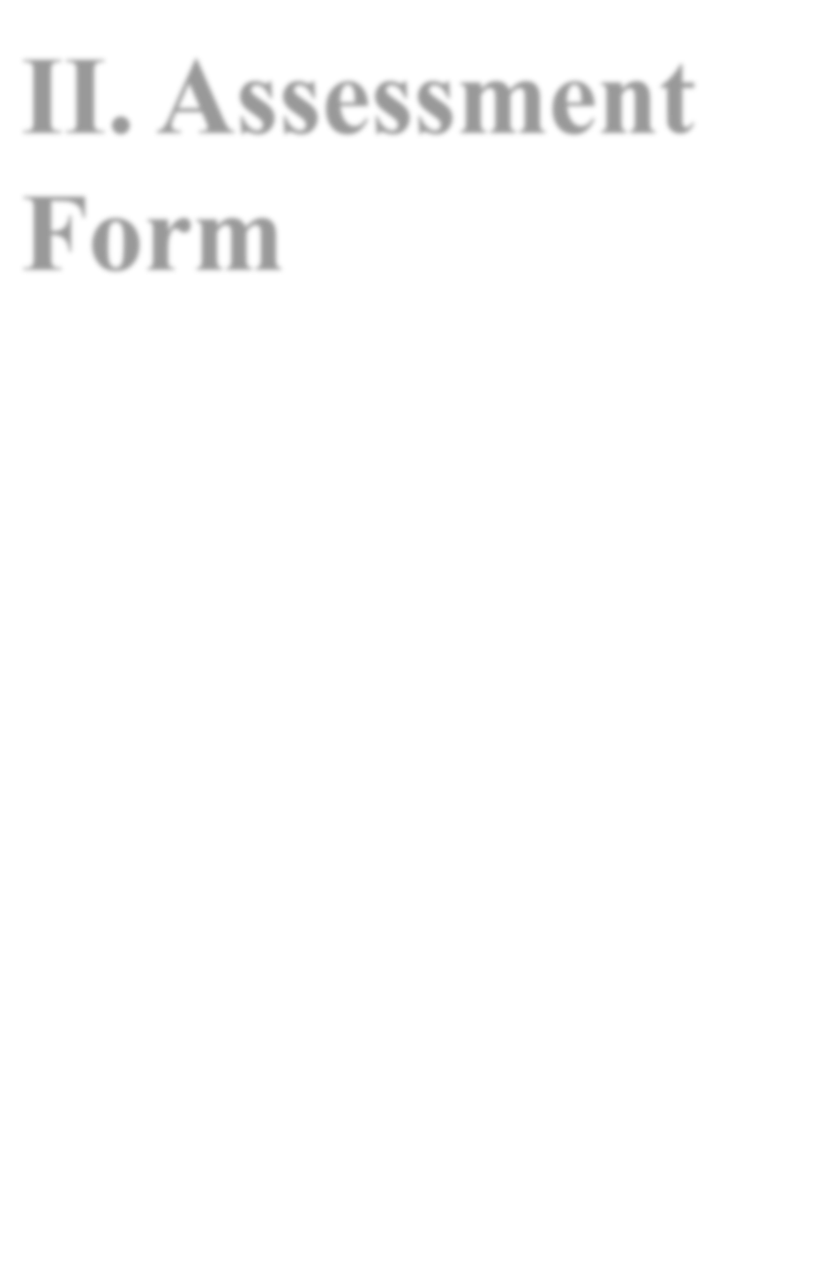Assessment Form

Part A
MIKE Intellectual Capital Assessment Criteria

There are two sections, in Part A.
- Do not just give normative statements that your organization treasures or values these factors. Please instead write narrative/stories on your concrete efforts you have put into each of the 8 criteria below with successful examples, photos, supporting data, events, news clippings or websites. A maximum write-up not more than two pages for each criteria is sufficient. Any extra materials could be attached in appendices. Power points would not be accepted but could be submitted as supplementary materials in appendices.

The questions/points given for each of the criteria are given in the table for your reference. They are only examples and hints of the content that are related to each of the criteria. There is no need to follow or answer each of them but just give you an idea what the criterion is about and to trigger your thought.

Criteria | Intellectual Capital Element
1. Empowering knowledge workers for innovation | Human Capital (HC)
2. Strategic, visionary and transformative leadership | Human Capital (HC)
3. Living up to customer and stakeholder expectations and needs | Relational Capital (RC)
4. Developing internal & external networks and connectivity | Relational Capital (RC)
5. Cultivating an organizational innovation culture | Structural Capital (SC)  -Innovation Capital
6. Investing in and delivering knowledge-based products/services/solutions | Structural Capital (SC)  -Innovation Capital
7. Enforcing knowledge practices and systems for knowledge creation | Structural Capital (SC)  - Process Capital
8. Implementing creative and virtual concepts / spaces to create stakeholder value | Structural Capital (SC)  - Process Capital

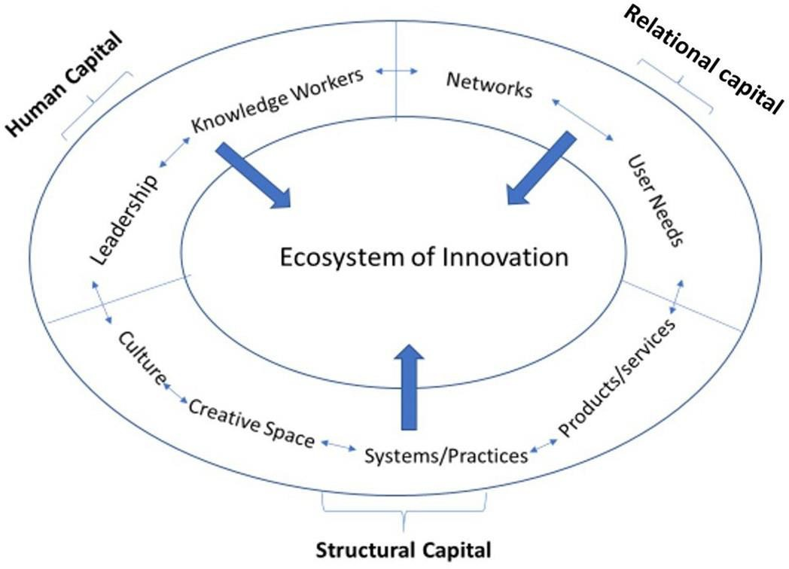

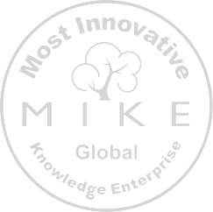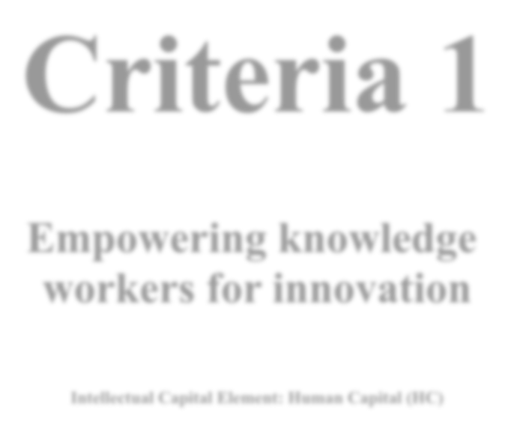Criteria 1

Empowering knowledge workers for innovation

Intellectual Capital Element: Human Capital (HC)

“What is the calculus of innovation? The calculus of innovation is really quite simple: Knowledge drives innovation, innovation drives productivity, productivity drives economic growth.”

William Brody
Hong Kong MIKE Award 2024 – V1-0

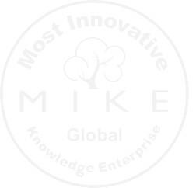
Hong Kong MIKE Award 2024 – V1-0

Suggested aspects to be addressed:
  - Talent acquisition, management & retention:
    - What initiatives make you attractive as an employer of choice of knowledge workers?
    - How do you ensure that you bring the right talents on board to execute your strategic agenda/roadmap? E.g., through cognitive assessments, internal assessment centers, headhunting, etc.
    - What is the percentage of workers in your organization with professional/ university qualifications? How does it compare to your industry standard?
    - How do you manage your talents to ensure knowledge workers' retention?

  - Learning and development:
    - How is your organization developing the new knowledge needed for your workers? E.g., internal training, internal training platform, knowledge sharing sessions, seminars, workshops, site visits, etc.
    - How many days per year does your average Knowledge Worker spend in training or learning and development initiatives? How does it compare to the standard market practice?
    - How does your organization develop and empower employees to contribute to sustainability-oriented innovation and long-term value creation? Provide examples of how employee wellbeing, inclusion, ethical practices, or sustainability-related competencies contribute to innovation and organizational performance.

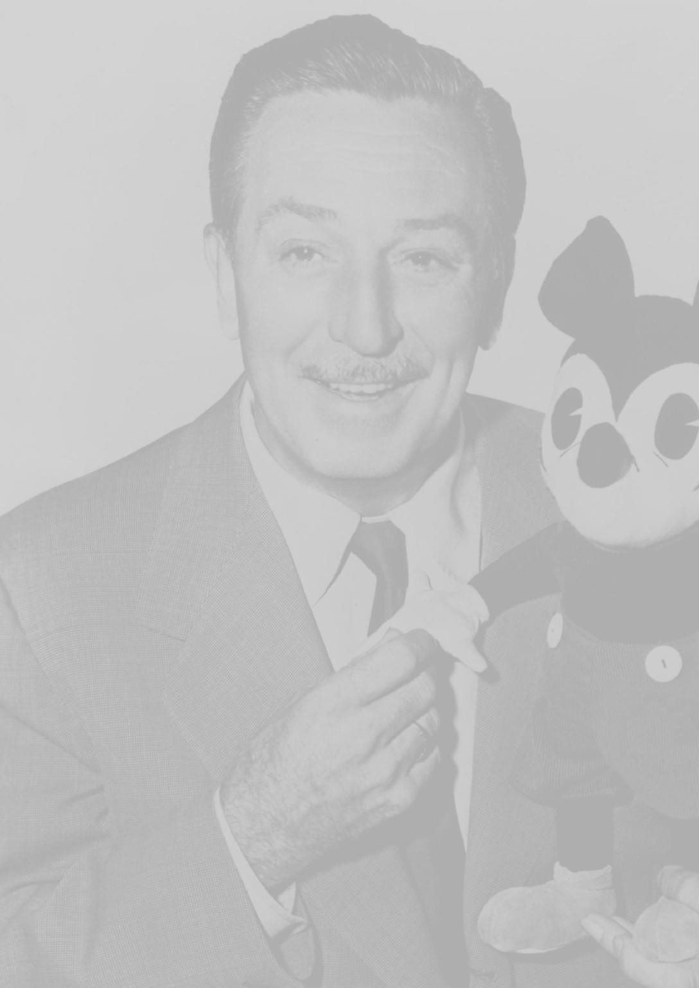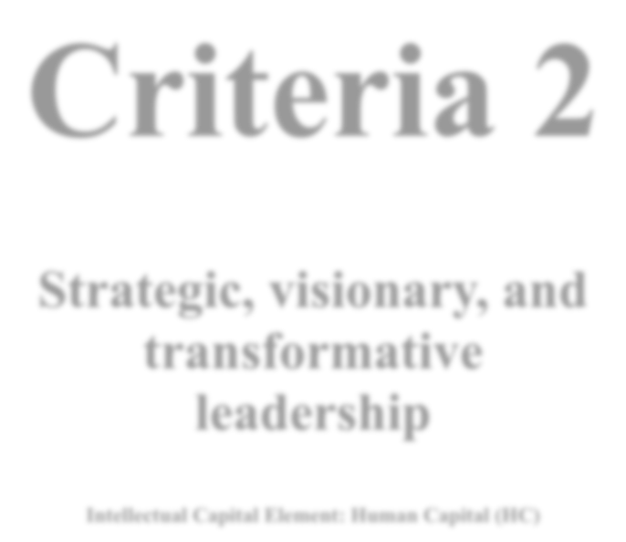Criteria 2

Strategic, visionary, and transformative leadership

Intellectual Capital Element: Human Capital (HC)

“Around here, however, we don’t look backwards for very long. We keep moving forward, opening up new doors and doing new things, because we’re curious... and curiosity keeps leading us down new paths.”

Walt Disney
Hong Kong MIKE Award 2024 – V1-0 - Revised on 9 February

Hong Kong MIKE Award 2024 – V1-0 - Revised on 9 February

Suggested aspects to be addressed:
  - Strategic core
    - What is the mission and vision of your organization?
    - What are the values of your organization?
    - To what extent does your essential strategic core (= mission, vision, values) reflect and focus on knowledge and innovation?

  - Executive leadership / senior management:
    - How do your leaders communicate the essential strategic core (= mission, vision, values) to internal and external stakeholders?
    - To what extent are these essential strategic parameters communicated and filled with life (animated with clear, concise, and practical messages and examples)?
    - Could you share some examples (activities and behaviors) of how some of your Senior Management Leaders showed their commitment and support for knowledge-driven and innovation initiatives and projects?

2. 3. Task leadership:
    - To what extent do task leaders of your organization exhibit entrepreneurial spirit, creativity, and (pro-) action-orientation?
    - To what extent can your task leaders make autonomous decisions on how they want to approach their projects to achieve the agreed-upon results and outcomes?
    - How does organizational leadership integrate sustainability, ESG principles, and long-term societal value into strategy and decision-making? Provide examples of leadership initiatives that promote responsible governance, sustainability transformation, or ethical innovation practices.

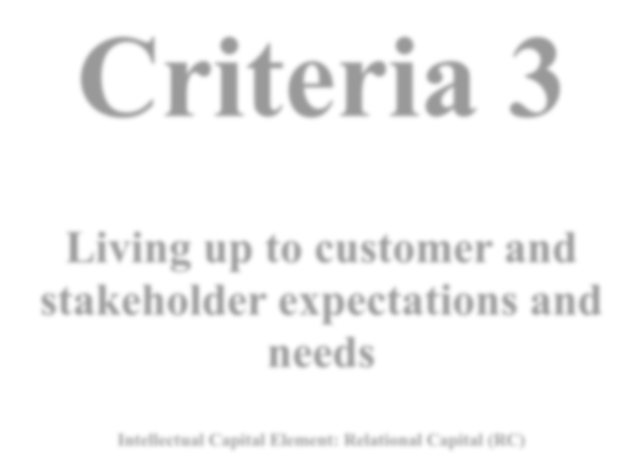Criteria 3

Living up to customer and stakeholder expectations and needs

Intellectual Capital Element: Relational Capital (RC)

“In business, the idea of measuring what you are doing, picking the measurements that count, like customer satisfaction and performance ... you thrive on that.”

Bill Gates
Hong Kong MIKE Award 2024 – V1-0 - Revised on 9 February

Hong Kong MIKE Award 2024 – V1-0 - Revised on 9 February

Suggested aspects to be addressed:
  - Living up to stakeholder expectations and needs
    - Who are the shareholders of your organization? Who are the other key stakeholders?
    - How are they being informed about the work and progress of your organization?
    - What value does your organization generate for its different stakeholders (e.g., better products and services, higher profits, greater corporate social responsibility, etc.)?

  - Living up to customer expectations and needs
    - How does your organization keep track of changes in markets and/or customer expectations?
    - To what extent, and how frequently, does your organization conduct any customer experience and satisfaction surveys? How do you apply the findings of these surveys?
    - To what extent do you involve your customers / clients in (co-) developing new products and services?
    - How does your organization handle customer complaints? To what extent do you act upon them? To what extent do you use them as a source of inspiration for product and service improvement throughout the organization?
    - How does your organization identify, understand, and respond to the sustainability expectations and concerns of customers and stakeholders? Provide examples demonstrating how sustainability initiatives have strengthened stakeholder trust, relationships, reputation, or societal impact.

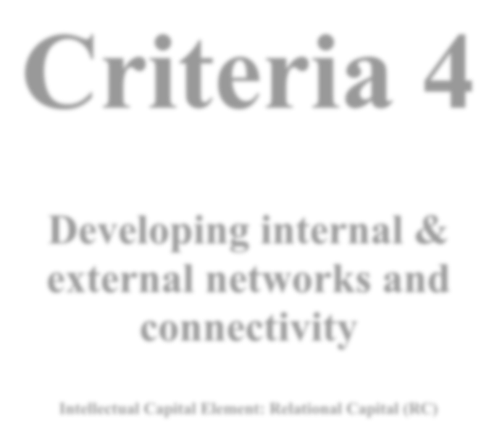Criteria 4

Developing internal & external networks and connectivity

Intellectual Capital Element: Relational Capital (RC)

“The new form of networking is not about climbing a ladder to success; it’s about collaboration, cocreation, partnerships, and long-term values-based relationships.”

Porter Gale
Hong Kong MIKE Award 2024 – V1-0 - Revised on 9 February

Hong Kong MIKE Award 2024 – V1-0 - Revised on 9 February

Suggested aspects to be addressed:
  - Developing networks
    - How do you encourage and foster internal networks and intra-organizational connectivity and collaborations?
    - What are the practices to build formal/informal internal and external networks?

  - Knowledge flows through networks
    - How is knowledge (explicit and experiential) acquired internally (e.g., personal networks, mentoring, project team, CoP, etc.)? How do you ensure it flows to the right person at the right time in the right format?
    - How is knowledge (explicit and experiential) acquired externally (e.g., consultants, trade networks, social media, university partnerships, crowdsourcing, open innovation, inter-organizational learning, strategic alliances, etc.)? How do you ensure it flows to the right person at the right time in the right format?
    - To what extent do you follow an ecosystemic approach towards knowledge management and innovation management?
    - How does your organization collaborate with internal and external partners to advance sustainability goals, responsible innovation, or societal value creation? Provide examples of partnerships, ecosystems, or collaborative initiatives that generated measurable environmental, social, or governance-related outcomes.

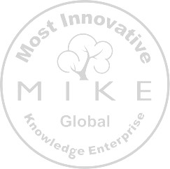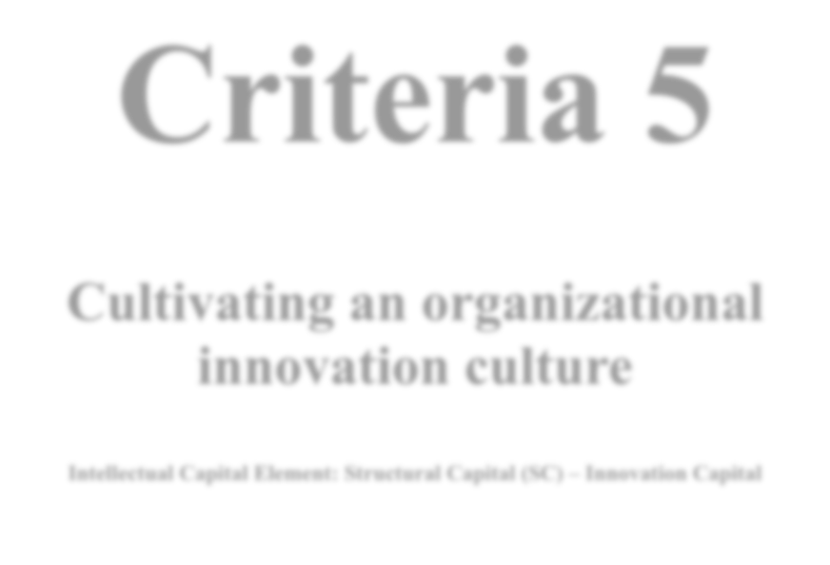Criteria 5

Cultivating an organizational innovation culture

Intellectual Capital Element: Structural Capital (SC) – Innovation Capital

“There are different ways to do innovation. You can plant a lot of seeds, not be committed to any particular one of them, but just see what grows. And this really isn’t how we’ve approached this. We go mission-first, then focus on the pieces we need and go deep on them and be committed to them.”

Mark Zuckerberg
Hong Kong MIKE Award 2024 – V1-0 - Revised on 9 February

Hong Kong MIKE Award 2024 – V1-0 - Revised on 9 February

Suggested aspects to be addressed:
  - Knowledge exploration and absorption
    - To what extent does your culture promote the concept of the learning organization? How have you designed your organizational learning or any action learning program?

    - How do organizational practices reflect a culture of knowledge creation and sharing among colleagues?

    - To what extent does your culture encourage vivid discussions and constructive debates on organizational issues and matters?

    - How does your organization encourage exploration of new knowledge and experimentation with it?

  - Idea generation and implementation
    - How do organizational practices reflect a culture of idea generation and sharing among your employees?
    - What is your organizational response to failure? How does your organization respond to people/teams taking the initiative and failing in a project? How do you learn from failures?
    - How does your organizational culture encourage sustainability-oriented innovation, responsible experimentation, and long-term thinking? Provide examples of initiatives, practices, or behaviors that promote sustainability values within the organization's innovation culture.

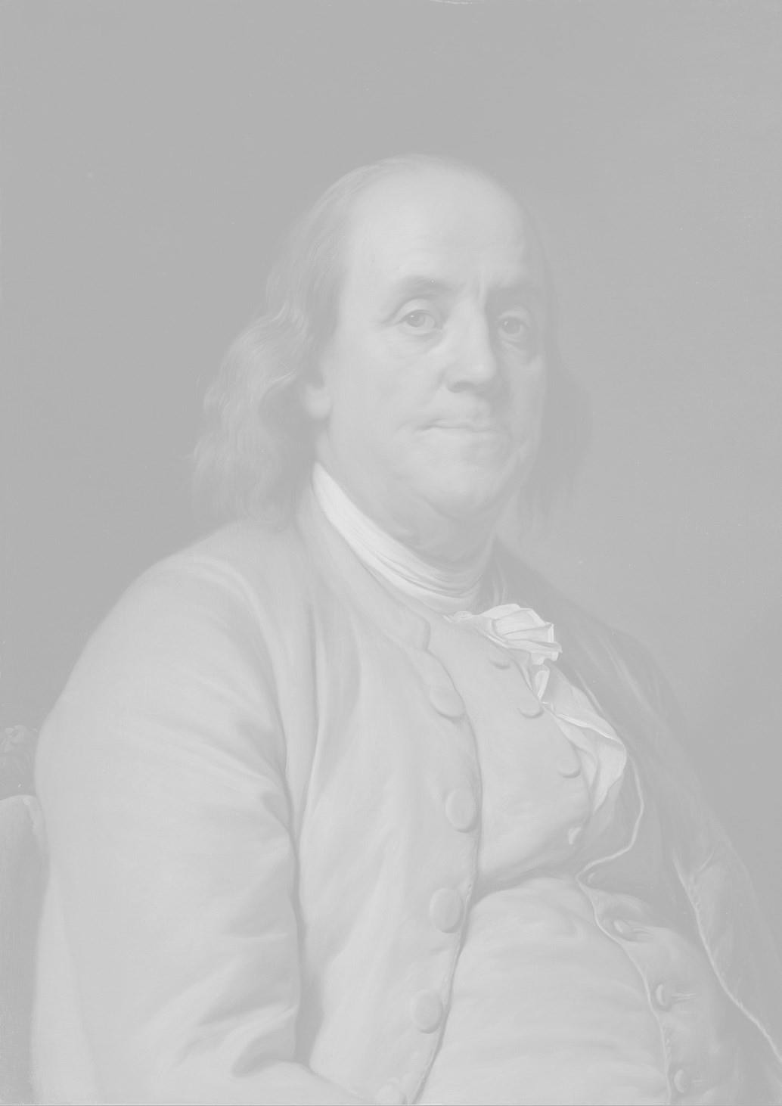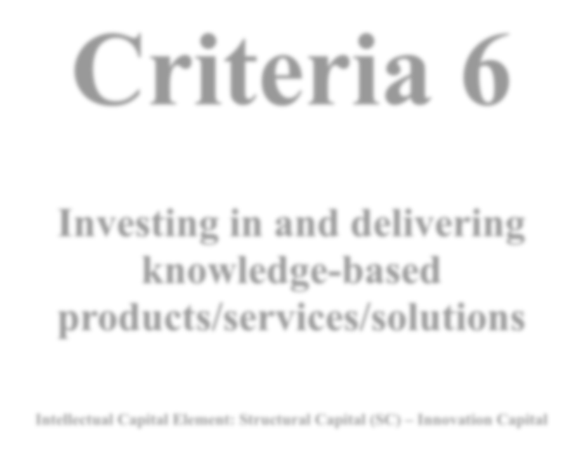Criteria 6

Investing in and delivering knowledge-based products/services/solutions

Intellectual Capital Element: Structural Capital (SC) – Innovation Capital

“An investment in knowledge pays the best interest.”

Benjamin Franklin
Hong Kong MIKE Award 2024 – V1-0 - Revised on 9 February

Suggested aspects to be addressed:
  - Investing in knowledge-based products/services/solutions
    - Does your organization as an Innovation Strategy? If so, how is it stated? Who is involved in formulating this strategy? In which way(s) does it support the overall strategy of your organization?
    - What is the percentage of your organization’s annual budget devoted to innovation / Research and Development (R&D)? How does this compare to the standard in your industry?
    - On average, how many innovation projects do you conduct per year? What is the average duration of these projects (here, you can distinguish between exploration, ideation & evaluation phases and the actual implementation phase if deemed appropriate)? How much do you spend per year on your innovation projects?
    - Which of the following 10 innovation types does your organization target (select all that apply)? A description of each innovation type can be found at: https://tinyurl.com/10typesinnovation

Share examples for the top 3 most used innovation types.
Configuration:
      - Profit Model Innovation (Business Model Innovation)
      - Network Innovation
      - Structure Innovation
      - Process Innovation
Offering:
      - Product Innovation
      - Product System Innovation
Experience:
      - Service Innovation
      - Channel Innovation
      - Brand Design
      - Customer Engagement (Experience Design)
    - What is the proportional mix of innovation projects (%) in your organization that targets incremental improvements, evolutionary innovations, and revolutionary innovations? Share some concrete innovation projects examples for each category.
Hong Kong MIKE Award 2024 – V1-0 - Revised on 9 February

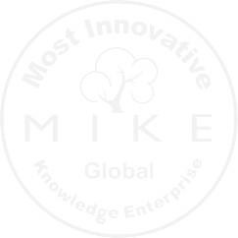
Hong Kong MIKE Award 2024 – V1-0 - Revised on 9 February

    - What is the uniqueness of the products, services, and solutions offered by your organization? How does this add value to your customers? Provide some examples to illustrate the uniqueness of your offerings.

  - Delivering knowledge-based products/services/solutions
    - How have you organized Innovation Management (IM) in your organization (governance)? At which hierarchical level is the “IM office” positioned? To whom is your most senior IM Officer reporting? Do you steer your IM initiatives in a centralized or decentralized committee / coordination group?
    - How does your organization recognize opportunities to develop new products, services, and solutions needed in the near future?
    - To what extent do mechanisms exist in your organization to capture ideas, opinions, and recommendations to improve any aspect of the business?
    - In what ways does your organization structure and systematically manage the process of developing new products or services so that they are addressing the emerging market needs?
    - What processes are in place to enhance knowledge creation and innovation related to your products and services range?
    - How does your organization design and deliver innovative products, services, or solutions that contribute to environmental, social, or societal value? Provide evidence of sustainability-related outcomes or impacts generated through your innovative offerings.

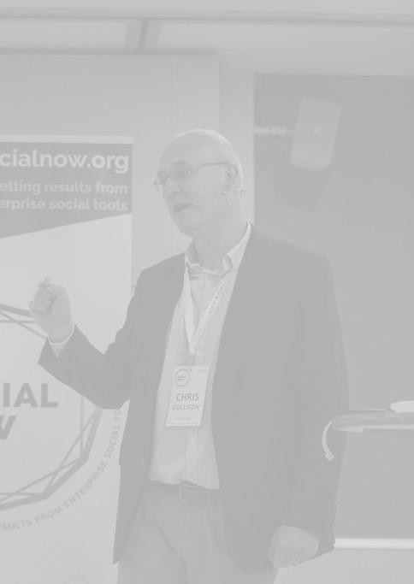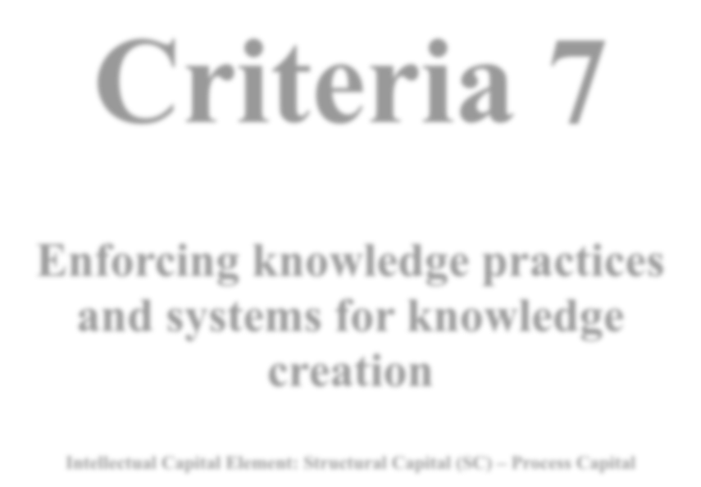Criteria 7

Enforcing knowledge practices and systems for knowledge creation

Intellectual Capital Element: Structural Capital (SC) – Process Capital

“You can’t manage knowledge — nobody can. What you can do is to manage the environment in which knowledge can be created, discovered, captured, shared, distilled, validated, transferred, adopted, adapted, and applied.”

Chris Collison
Hong Kong MIKE Award 2024 – V1-0 - Revised on 9 February

Hong Kong MIKE Award 2024 – V1-0 - Revised on 9 February

Suggested aspects to be addressed:
  - Strategic knowledge management
    - Does your organization as a Knowledge Management Strategy? If so, how is it stated? Who is involved in formulating this strategy? In which way(s) does it support the overall strategy of your organization?
    - How do you identify and map critical knowledge in your organization?
    - To what extent are you aware of any knowledge risks in your organization? What measures have you taken to mitigate or eliminate these risks from their occurrences? How do you prevent of critical or confidential knowledge from leaving or leaking from your organization?
    - How have you organized Knowledge Management in your organization (governance)? At which hierarchical level is the “KM office” positioned? To whom is your most senior KM Officer reporting? Do you steer your KM initiatives in a centralized or decentralized committee/coordination group?
    - What systematic practices and processes does your organization use for identifying and capturing knowledge (both external and internal)? And for organizing and sharing it throughout your organization?

  - Operational knowledge management
    - What are the information tools and platforms (KMS) available in your organization that support the flow of relevant information and knowledge among your employees? What is the employee usage level of your KMS system? How do you measure the success of such systems? Please share some of these metrics and results.
    - Has your organization developed any knowledge repository of your knowledge workers’ skills and competencies (expertise locator)? How are knowledge workers' competencies (knowledge skills and experiences) identified, maintained, and kept up to date in this system?
    - To what extent do you use mentoring/tutoring programs for junior employees to get up to speed more rapidly? To support knowledge transfer between generations?
    - Does your organization offer/support any opportunity or channels for employees to socialize and share experiential knowledge and learn from each other? Please provide examples.
    - How does your organization capture, manage, and share sustainability-related knowledge, lessons learned, and best practices? Provide examples of how knowledge management practices or systems contributed to improved sustainability, ESG, or responsible governance performance.
    - Does your organization offer/support any type of cross-divisional communities of practices/innovation for employees to share experiential knowledge, learn from each other and collaboratively develop solutions, new tools, etc.? Please provide examples.

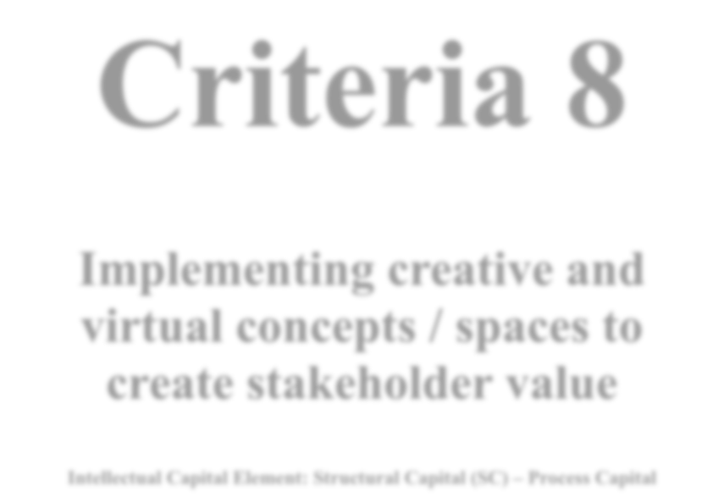Criteria 8

Implementing creative and virtual concepts / spaces to create stakeholder value
Intellectual Capital Element: Structural Capital (SC) – Process Capital

For innovation to flourish, organizations must create an environment that fosters creativity; bringing together multi-talented groups of people who work in close collaboration together — exchanging knowledge, ideas and shaping the direction of the future.

Hong Kong MIKE Award 2024 – V1-0 - Revised on 9 February

Suggested aspects to be addressed:
Describe with concrete examples to what extent your organization has adopted, implemented, and successfully used one or more of the following concepts to enhance the interactions, creativity, and learning of employees in your organization:

- Collaborative workplaces;
- Social media;
- Innovation jam;
- Smart office; Floating/mobile office;
- Future Centre; User Lab, Mind Lab, etc.;
- Knowledge café, dialogue circles etc.;
- Others.

Provide concrete evidence and/or examples of benefits and outcomes associated with the application of one or more of these concepts.
How does your organization use digital, virtual, or collaborative environments to support sustainability, inclusion, stakeholder engagement, or responsible innovation? Provide examples showing how creative spaces, digital platforms, or virtual initiatives contributed to sustainable stakeholder value creation.

Criteria Ranking

- Among the 8 criteria, please give a rating (from 1 to 7) in the form of a score to the relative importance of each of these criteria which you think is important to the success of your organization. Also please pick up any THREE criteria (put a tick in the box) which your organization has performed most well.

Criteria | Relative Importance of the Sustainability Criteria  7 - Extremely important (critical to success) 6 - Very important (essential in most aspects) 5 - Important (essential in some aspects)  4 – Somewhat important (nice to have)  3 – Fairly important (needed in some aspects)  2 – Slightly important (needed in a few aspects only) 1 - Not important at all (would not affect operation)  (Please put down your rating below for each one, identical rating is permitted) | Select  THREE  criteria your organization has performed best  (put a ✓  below)
1. Empowering knowledge workers for innovation
2. Strategic, visionary and
transformative leadership
3. Living up to customer and
stakeholder expectations and needs
4. Developing internal & external networks and connectivity
5. Cultivating an organizational innovation culture
6. Investing in and delivering knowledge-based products/services/solutions
7. Enforcing knowledge practices and systems for knowledge creation
8. Implementing creative and virtual concepts / spaces to create stakeholder value

Part B
Innovation Performance

How do you measure innovation performance in your organization? Please select the most appropriate measurement indicator(s) for your organization and provide a self-appraisal with data and evidence. You may select more than one measurement area and describe how exactly you measure your innovation performance for each selected area.
How do these innovation efforts contribute to sustainable economic, social, environmental, or stakeholder value creation?
  - New products / services/ brands / business models developed
  - Market share / new product sales
  - Patents / licenses / royalties
  - Process, technology or channel improvements
  - Revenues / incomes / turnover
  - Customer / client satisfaction
  - Prizes / awards / honors, etc.
  - Ideas in (closed and open) innovation pipelines, etc.
  - Others …

Appendix Document

